OBITUARY

Professor Richard Pipes obituary
Historian who escaped from the Nazis and spent his life warning of the dangers posed by the authoritarian regime in the Soviet Union
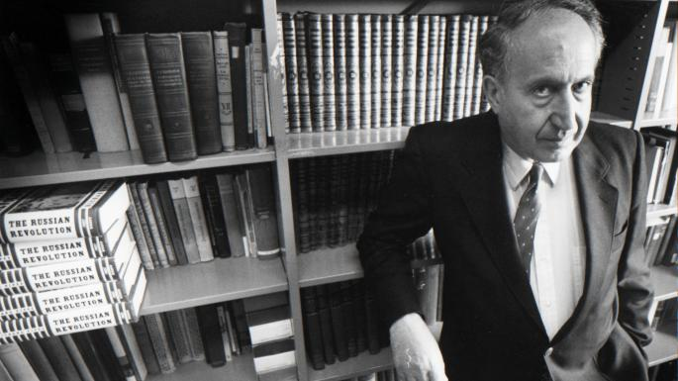
Richard Pipes at Harvard, where he taught for almost 40 years, in 1991AP

June 19 2018
https://www.thetimes.co.uk/edition/register/professor-richard-pipes-obituary-hfvg5wggd
When Richard Pipes, a young Polish-Jewish emigrant to the United States, began in 1945 to discover what had happened to much of his extended family during the Holocaust, he made a number of life-changing decisions. After reading letters from a few surviving relatives about brutal deportations and death camps, he avoided pursuing much more knowledge “for the sake of my sanity and positive attitude to life”. At the same time, he concluded that his own immediate family’s miraculous escape from Nazi-occupied Poland in 1940 should make him “delight in every day of life that has been granted to me, for I was saved from certain death”.
His life was not to be wasted, but used “to spread a moral message by showing, using examples from history, how evil ideas lead to evil consequences”. Rather than studying the horrors perpetrated by the Nazis, “I thought it my mission to demonstrate this truth using the example of communism”.
Pipes went on to make his career at Harvard where he became one of the best-known historians of Russia and the Soviet Union. He saw significant continuities between tsarist imperialism and authoritarianism and what followed the 1917 Revolution, and wrote unfashionably and unflinchingly about the personal evils and culpability of communist leaders such as Lenin and Stalin. And he took his academic perspective of Russian behaviour into a brief but highly influential political role as an adviser to President Reagan in the early 1980s, persuading him to adopt a less compromising approach towards Moscow in the belief that the Soviet Union could not survive a sustained economic and military challenge.
Such was Pipes’s prominence that the Kremlin published a book denouncing him as the “Falsifier of History”. While critics accused him of Russophobia, Pipes insisted that “I draw a sharp distinction between Russian governments and the Russian people”.
Although Russia later became the focus of his interest, it was Poland and Germany that dominated his early life. Richard Edgar Pipes was born in 1923 in the town of Cieszyn on the Polish-Czech border. His mother, Zosia, was just 21. His parents, who moved to Warsaw, were Jewish but non-observant. They spoke Polish and German and regarded themselves as well integrated. They were prosperous too, with his father, Marek, involved in the manufacture of chocolate and the import of fruit. Richard was their only child.
The German invasion of Poland in 1939 exposed his family’s vulnerability. Pipes recalled watching the German bombers from his window, “a formation of silvery planes heading for Warsaw”. He was forced into hiding, fearing deportation. “All my ambitions, plans and dreams lay shattered.”
Months spent watching the aftermath of the Nazi occupation, and the passivity of many Poles, also left Pipes with “the abiding conviction that the population at large plays only a marginal role in history, or at any rate in political and military history, which is the preserve of small elites; people do not make history — they make a living.” It made him instinctively sceptical as a historian about the increasing popularity of the idea that history was “made from below” by social movements.
Eventually, as his father exploited his contacts, the family managed to obtain papers to take them as far as Italy, which in 1940 was not yet implementing the harshest antisemitic measures. They were able to remain there until they were ready to make their final escape to the US in a Greek ship sailing from Portugal. Pipes arrived in New Jersey on July 11, 1940, his 17th birthday.
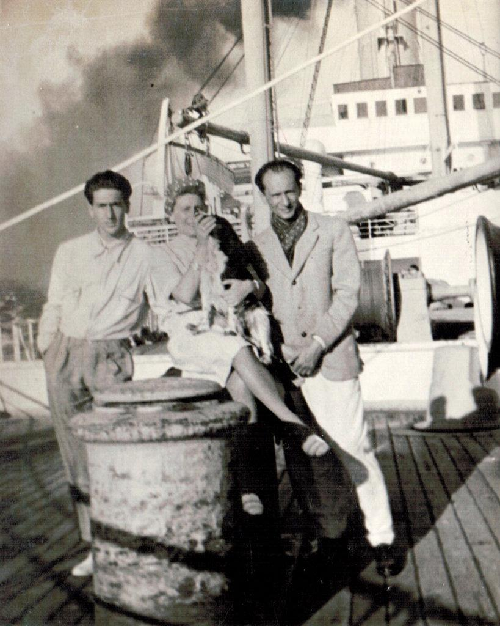
Pipes fleeing Europe for the US with his parents, Zosia and Marek, in 1940
He set about acquiring an education, enrolling at an Ohio college and then enlisting in the US Army Air Corps in 1942, and was sent to Cornell University to learn Russian in preparation for US-Soviet military co-operation against Germany. In the end he did not see active service and after discharge from the military in 1946 he married Irene Roth, whom he had met at Cornell in 1944. She survives him with their two sons: Daniel, who also became a historian and is president of the Middle East Forum, and Steven.
According to Daniel, his father was a serious man, but not a sombre one. He was a skilful raconteur who regaled his children with “imaginative bedtime stories” and “enjoyed silly television shows” such as the BBC’s Keeping Up Appearances. He was also a connoisseur of fine wine, and a devoted fan of the actress Greta Garbo.
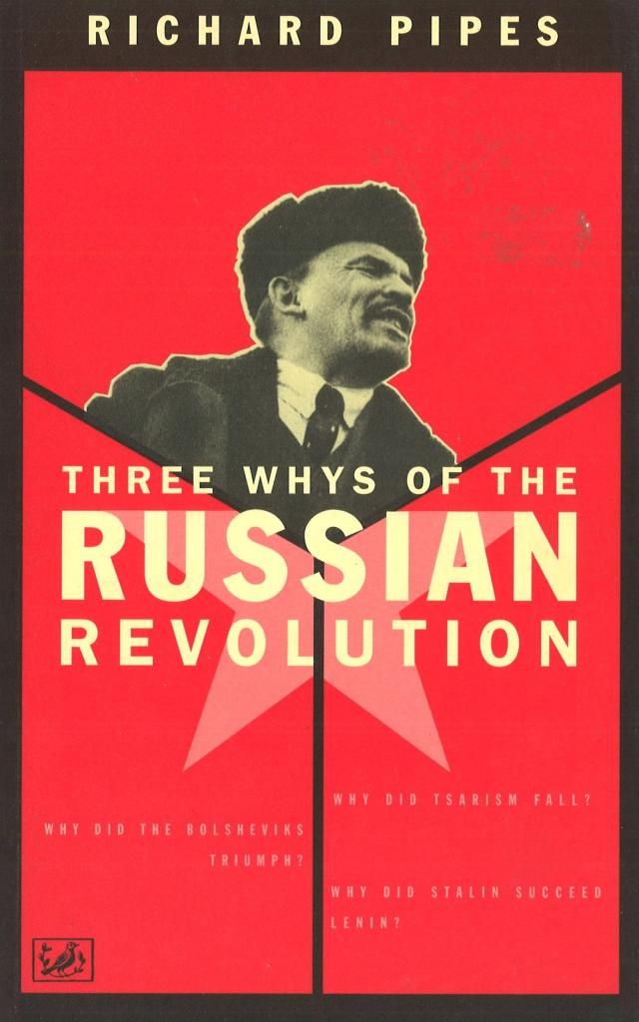
At about the same time as his marriage, Pipes made his decision to pursue an academic career in Russian history and won tenure at Harvard in 1958. His first book was The Formation of the Soviet Union. He wrote or edited about 20 more, notably: Russia Under the Old Regime; an extensive account of the Russian Revolution, in 1990; and Communism: A History published in 2001.
His study of the 1917 revolution, and the rapid centralisation and brutal enforcement of Bolshevik power, persuaded him that the Soviet Union was in some ways a successor to earlier Russian imperialism, a “patrimonial state” in its authoritarian instincts and contempt for individuals and their rights. He also saw the Bolsheviks as taking the use of violence and terror to new levels, describing Lenin’s “strong streak of cruelty” and publishing documents showing him urging the murder of opponents among the bourgeoisie and the church. Pipes also documented in chilling detail the routine murder of thousands during Stalin’s Great Terror. He accused historians who omitted such material of “writing bloodless history about a time that drowned in blood”.
Pipes’s own visits to the Soviet Union confirmed his bleak view about the place and its regime. He remembered a woman on a tram in Leningrad in 1957 whispering to him: “We live like dogs, don’t we?”
Yet that sense of the misery of Soviet life also led him to believe that the Soviet system could not last, especially if put under pressure by the West. He became a prominent critic of what he saw as the appeasement of the Soviet Union by the US and other countries, and was recruited by the new Reagan administration in the early 1980s as a national security adviser.
He issued a warning that Soviet leaders might believe they could fight and win even a nuclear war, so the US needed to build up its defences accordingly. He also expressed confidence that, if challenged in the right way, the Soviet Union would be forced to change or cease to exist. His advice became the base of a famous speech, which Reagan gave to the British parliament in 1982, that foresaw a “march of freedom and democracy which will leave Marxism-Leninism on the ash heap of history”.
As Pipes recalled, Reagan was “altogether incapable of thinking abstractly” and hardly ready for full intellectual engagement with Pipes’s theories, preferring instead to muse on whether the distribution of a million Sears Roebuck catalogues in the Soviet Union might bring down the regime most quickly. However, he praised Reagan’s intuitive understanding of the need for strength. “How did it happen that this man, regarded by the intelligentsia as an amiable duffer, grasped that the Soviet Union was in the throes of terminal illness, whereas nearly all the licensed physicians certified its robustness?”
The Kremlin took Reagan’s new adviser seriously enough to publish a book entitled Richard Pipes: Falsifier of History, which Pipes enjoyed distributing to friends, just as he seemed to enjoy his liberal critics’ view of him as a “Cold Warrior”. He later began to find the intrigues of Washington power struggles wearying — he was himself seen as an often prickly character — and returned to academic life in Harvard.
From there he watched the ascent of Mikhail Gorbachev, whose reformist instincts he was slow to appreciate, and then the implosion of the Soviet Union he had predicted. Yet Russia’s evolution under Vladimir Putin renewed Pipes’s fear that, even after the end of communism, autocratic rule was far from over.
After his retirement he still took on a significant study of Russian thought and published a memoir entitled Vixi, which is Latin for “I have lived”. Among many honours he received one of the most moving was the award of honorary citizenship back in his home town of Cieszyn — a place to reflect on how easily the brutal totalitarian world he went on to describe and explain so memorably might have ended his life before it had really begun.
Professor Richard Pipes, historian, was born on July 11, 1923. He died on May 17, 2018, aged 94

